Statement of Work – Short Form Consulting Project

Partners Life – SOW09: Shared APIM
Consultants: | Jacky Wang, Senior Cloud Engineer,  Andrew McDowell, Principal Architect
Background | Partners Life Limited (Partners Life) has several Azure API Management (APIM) services deployed to support API integrations across it’s Evince and MyPartnersLife (MPL) solutions. MPL is currently in the process of being moved into PAE Gen2 and this activity offers an opportunity to establish a consolidated Azure APIM (a.k.a. Shared APIM) available to MPL, Evince, and other Azure based workloads. This will help to control Azure resource costs and centralise administration of Azure hosted API services within Partners Life.  A review of the deployment options available for APIM recommended the use of the Centralised model over the Siloed and Federated models. Using a Centralised deployment for APIM allows multiple sets of APIs spanning multiple workloads to be deployed on a single instance of APIM.  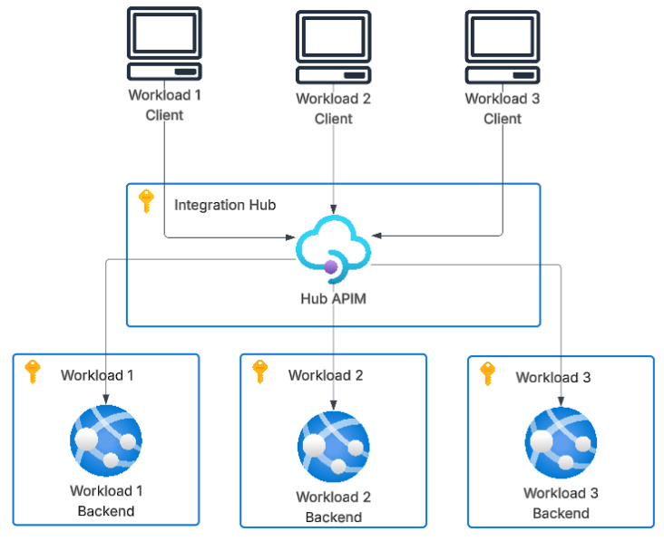  The full list of recommendations from the APIM deployment review were as follows;  - Due to the current limitations of Workspaces in APIM that implement the Federated model, the Centralised APIM model is recommended. API's can be deployed at the APIM Service level to consolidate infrastructure costs and governance overhead. Once Workspace functionality becomes more fully featured later in 2026, Workspaces can be added to the centralised APIM to provide isolation for new workloads.  - The APIM V2 family should be preferred for the Centralised APIM. While the APIM Classic family is more fully featured than the APIM V2 family, the lack of an in-place upgrade from Classic to V2 and the likelihood that new APIM features will target the V2 family weigh in its favour.  - APIM Standard V2 should be preferred for the Centralized APIM at this time. The additional features available in Premium V2 are not essential for the MPL deployment (first deployment on the centralised APIM) and they do not justify the additional cost. The Standard V2 also provides features currently used by the Evince Production APIM.  - Separate the deployment of the APIs from the deployment of the APIM infrastructure. This will allow the APIM infrastructure to be redeployed easily if Premium v2 tier is needed.  - Deploy three centralised APIM's – one in each of the Integration Hub subscriptions (Dev, UAT and Prod).
Service Description (Scope Inclusion): | The scope of the work Equinox IT will perform in this project includes:  - Removing the ACS instance created for the POC.  - Setup a new Azure DevOps repo in the Integration Hub project to host the Terraform and deployment pipeline for the Shared APIM resource.  - Deploying up to three Standard V2 instances (Dev, Test and Prod) of the Shared APIM into the PAE Gen2 Integration Hub subscriptions.  - Establishing logging and alerting for the based APIM resource.  - Creating as-built / solution description documentation for the Shared APIM solution including guidance on how Workload APIs should be managed and deployed onto the Shared APIM.  - Raising change requests, attending meetings, coordination, and project administration.  - Collaborating with Partners Life and their vendors as required to achieve the objectives of this SOW.
Service Description (Scope Exclusion): | Items excluded from the scope are:  - Configuring alerting or monitoring for workload APIs deployed into the Shared APIM. Workload API monitoring and alerting requirements can be determined in consultation with the vendor responsible as part of deploying a new workload onto the Shared APIM.  - Ongoing support for the Shared APIM once deployed. Ongoing support will be provided under the Azure Managed Services agreement between Partners Life and Equinox IT.  - Any licensing or subscription fees.  - Any other work item not mentioned in the Scope Inclusions above.

Assumptions: | Assumptions impacting this Statement of Work:  - The MPL project is dependent on the completion of this SOW and the Shared APIM will need to be deployed as rapidly as possible.
Formal Deliverables: | The formal deliverables of this project will be:  - Standard V2 Azure API Management service deployed in the Dev, Test and Prod Integration Hub subscriptions.  - As built / solution description documentation describing the Shared APIM and its configuration.
Client billing contact: | James Thornhill  Partners Life  Email: jamesthornhill@partnerslife.co.nz
Cost: | Equinox IT will commit up to 61 hours for this assignment, at a cost of $14,335 excluding GST. This estimate is based on the table below.  Description Hours Hourly Rate Estimated Cost  Terraforming APIM, setup deployment pipeline, logging and alerting, and deployment 35 $235 $8,225.00  As-built / solution description 9 $235 $2,115.00  Project coordination 9 $235 $2,115.00  Contingency 8 $235 $1,880.00  Total fees 61 $14,335.00
Fine print: | Pricing and Invoicing  - All prices or fees exclude GST except where noted or not applicable.  - This project will be invoiced on a Time & Materials basis.  Expenses  - Pricing excludes incidental expenses such as travel and accommodation.  - The Equinox IT policy for expenses is to seek prior approval before costs are incurred.  - Travel expenses will be passed on at our cost without added margin.  Terms of Business  - This quotation is subject to the Master Services Agreement between Partners Life Limited and Equinox Limited, dated 2 September 2025.  - Consultant(s) may use Artificial Intelligence (AI) tools to enhance efficiency, analysis, and productivity in delivering services under this agreement. Consultant(s) remains responsible for ensuring the accuracy, quality, and compliance of all deliverables. If requested, we will disclose the AI usage relevant to the engagement.  Validity  - This quotation is valid for 28 working days from the date of the quote.

Acceptance

For Partners Life by: For Equinox IT by:

____________________________________ __________________________________
Signature Signature

____________________________________ __________________________________
Name Name

____________________________________ __________________________________
Position Position

____________________________________ __________________________________
Date Date

